
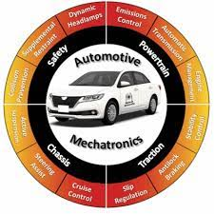


Adaptive AutoSAR Communication Stack

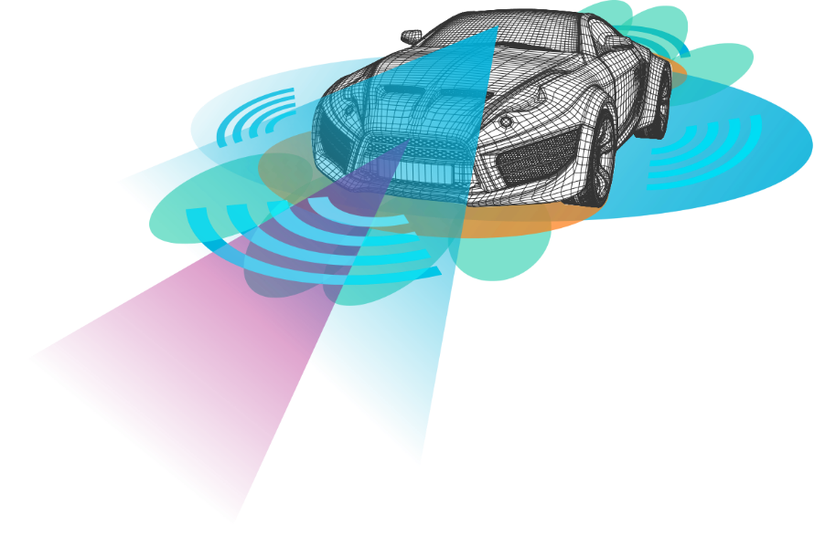
Name | Department | ID | Role
Mustafa Mahmoud Tawfeeq | Automotive Mechatronics | 302017162 | AutoSAR Developer
Ahmed Magdy Mahmoud | Automotive Mechatronics | 302020228 | MCU hardware expert
Abdallah Essam El-Sayed  (Team Leader) | Automotive Mechatronics | 302020233 | Embedded C++ Developer
Ahmed Kamal Elgarnousy | Automotive Mechatronics | 302020226 | Embedded C/C++ Developer
Shams Al-din Gamal | Automotive Mechatronics | 302021102 | Embedded C++ Developer
Motaz Usama Abd-AlKareem | Automotive Mechatronics | 302021168 | AI Developer
Mina Farid Shawky | Automotive Mechatronics | 302021162 | AI Developer
Author’s information
Abstract

The project aims to enhance the urgent need for simplify the increasing complexity of modern vehicles and Automotive Trends and their enablers, Adaptive AUTOSAR paves the way for enhanced functionalities, greater flexibility in ECU software in vehicles, and improved performance in the realm of automotive computing platforms, a major step in the direction of fully automated and networked driving. Adaptive AUTOSAR is not a replacement for Classic AUTOSAR. Its strength lies instead in a smart combination of both standards.
Communication middleware allows for flexible and scalable communication between software components, which is essential in the dynamic and complex environments of modern vehicles. It can handle various data rates and adapt to the growing number of connected devices and services. We are delighted to extend a warm welcome to you for our Adaptive AUTOSAR communication stack GP.

Contents
Introduction 4
Problem Statement 5
Purpose statement 6
Architecture 7
Functional Clusters 7
Dependencies 8
• Crypto Provider 8
• Operating System 8
• Watchdog 8
External Systems communication 8
AUTOSAR Adaptive Application 9
AUTOSAR Classic Platform 9
Third-party Platform 9
Diagnostic Client 9
Backend 9
AUTOSAR Adaptive Comm Stack requirements 10
Compatibility 10
Usability 10
Maintainability 10
Portability 10
SOME/IP 11
Remote Procedure Call (RPC) and Messaging 11
Serialization 11
ARA::COM 12
Service Discovery 12
Design decisions 13
Service interface 13
Resources 14
Software 14
Hardware 14
Agile methodology 15
Conclusion 16
References 17

Introduction
In the fast-evolving automotive industry, rapid technological advancements bring both challenges and opportunities. The demand for new systems is driven by the increasing complexity of software and data exchange in vehicles. Key factors include Autonomous Driving, V2X applications, and enhanced connectivity for Intelligent Vehicles.

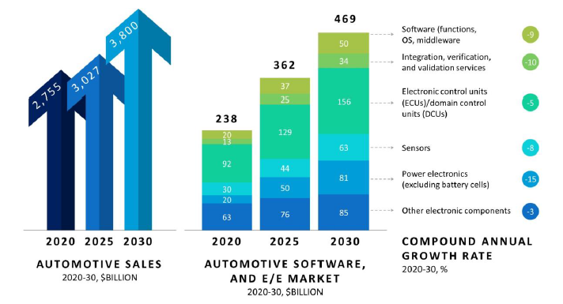
A McKinsey report predicts substantial growth, with a 7% annual increase, in the market for automotive software and electrical/electronic components. This market is set to expand from $238 billion in 2020 to a projected $469 billion by 2030.

To meet these emerging needs, the traditional AUTOSAR Classic architecture falls short, especially for high-end applications requiring real-time data from multiple sensors and seamless communication with the environment. Some applications involve critical safety decisions based on this data.

Adaptive AUTOSAR is an extension of the AUTOSAR standard, designed to meet the specific needs of connected and autonomous vehicles. In this context, communication and middleware play a crucial role in enabling the exchange of data and services between various components and systems within the vehicle.

Problem Statement
Due to modern vehicles and Automotive Trends many technologies are being developed now and in the future. New functionalities such as environment perception, autonomous driving, vehicle connectivity and Car as a Service (CaaS), Networking the vehicle with the surrounding road traffic (“V2X”), Applications with continual “over-the-air” updating, Multimedia applications (e.g. music streaming, online navigation, etc.), many new functionalities and also many complexities have introduced a new set of problems to the electrical/electronic (E/E) architecture.
They are different/complex to the ones ClassicAS was designed for. These new functionalities are expected to evolve during the vehicle’s lifetime. High complexity leads to high computing power, faster communications and continuous updates is absolutely needed.
HPC has many cores, processors, GPUs, and other processing units. Classic AutoSAR, already struggling with multi-core ambients, cannot define a solid structural model for the new processing needs. Similarly, even though the higher bandwidth provided by ethernet is already in use by Classic AutoSAR, this architecture cannot completely harness its power. Furthermore, the static nature of Classic AutoSAR makes it inflexible in certain aspects. For example, its scheduling algorithm doesn’t allow it to dynamically assign tasks to cores, meaning the usage at one core could be nearing 100%, while another one is barely used.
Taking these new aspects into account, ClassicAS is not enough to design software that suits these new inputs.

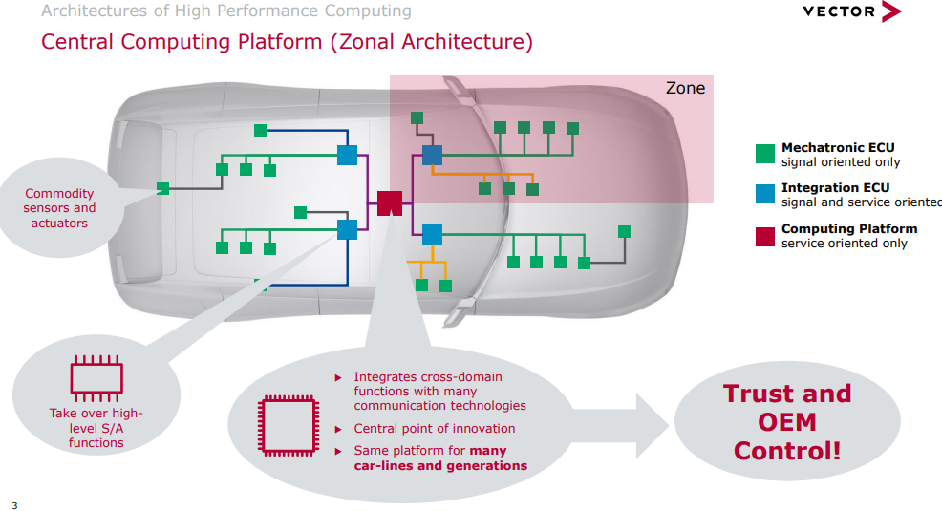

Purpose statement

Adaptive Autosar is to achieve a more flexible, dynamic, and expandable system. To better utilize the capabilities of HPC with a different architecture than the one introduced by Classic AutoSAR conserving the layered architecture which distinguish the AUTOSAR platform.

The final decision to come up with a new and AUTOSAR-specific Communication Management API was made due to the fact, that not all of our key requirements were met by existing solutions:
- We need a Communication Management, which is NOT bound to a concrete network communication protocol. It has to support the SOME/IP protocol but there has to be flexibility to exchange that.
- The AUTOSAR service model, which defines services as a collection of provided methods, events and fields shall be supported naturally/straight forward.
- The API shall support an event-driven and a polling model to get access to communicated data equally well. The latter one is typically needed by real-time applications to avoid unnecessary context switches, while the former one is much more convenient for applications without real-time requirements.
- Possibility for seamless integration of end-to-end protection to fulfil ASIL requirements.
- Support for static (preconfigured) and dynamic (runtime) selection of service instances to communicate with.
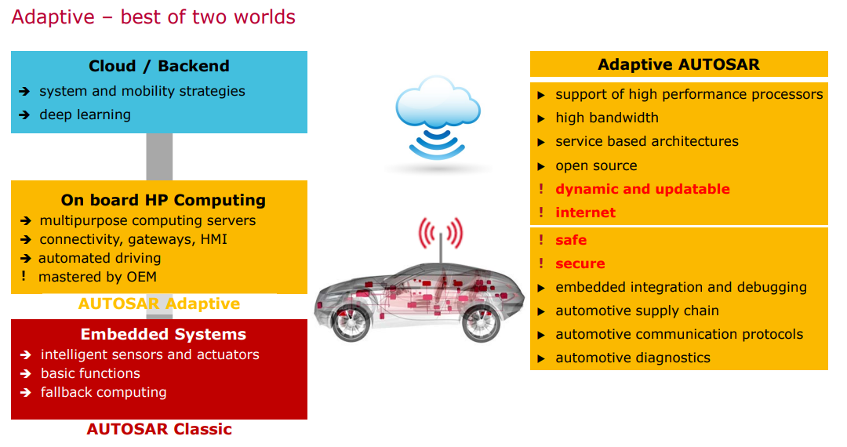
Through this project, we will customise an image using yocto and build an adaptive application over ethernet with the concern of com stack implementation.

Architecture
The Adaptive AS architecture is based on key principles, such as C++ as the preferred language, Service Oriented Architecture (SOA), dynamicity, and inherent parallelism.
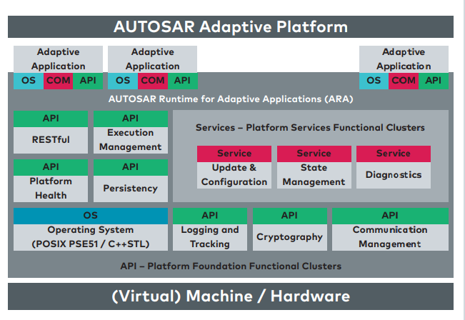
But what is SOA? SOA can be defined as a model in which services are made available across a network. The services can reside either in the same ECU or externally in another ECU. Furthermore, the services are self-contained units; the clients (the users of services) are independent of the services. In addition, the coupling between services and clients is dynamic at run time.

At the top layer, we can find the new Adaptive Applications (AA). AAs, in contrast to software components (SWCs), are now processes that may be single or multi-threaded. Another important characteristic of them is they are now able to be started or stopped at any time.
This new ARA is made up of application interfaces coming from the building blocks of the next layer, that is, the functional clusters. Moreover, such functional clusters can be either from the Adaptive Platform Foundation or the Adaptive Platform Services. Another key aspect to understanding the ARA is that in contrast to the runtime environment (RTE) and therefore with the ClassicAS, in AdaptiveAS the clients and services are dynamically linked at runtime.

Functional Clusters
The software of the Adaptive Foundation and Adaptive Services is presented in the form of functional clusters. Their main purpose is to offer functionalities in the form of services to the application. However, being part of the new Adaptive Platform, and in contrast to the BSW, the new functional clusters are now processes, which can be single-threaded and multithreaded. Another key feature is the dynamicity vs. the traditional static nature of the BSW.

Dependencies

Crypto Provider
Crypto Provider is a component that provides implementations of cryptographic routines and hash functions to the AUTOSAR Adaptive Platform.
- Runtime
- Communication
- Storage
- Security
- Safety
- Configuration
- Diagnostics

Operating System
The Operating System is the main component that AUTOSAR Adaptive Platform uses to provide its services. The Operating System controls processes and threads and provides inter-process communication facilities. The Operating System also provides access to network interfaces, protocols like TCP/IP, and access to non-volatile storage.

Watchdog
The Watchdog is a component to control the hardware watchdog of the machine an AUTOSAR Adaptive Platform runs on.

External Systems communication
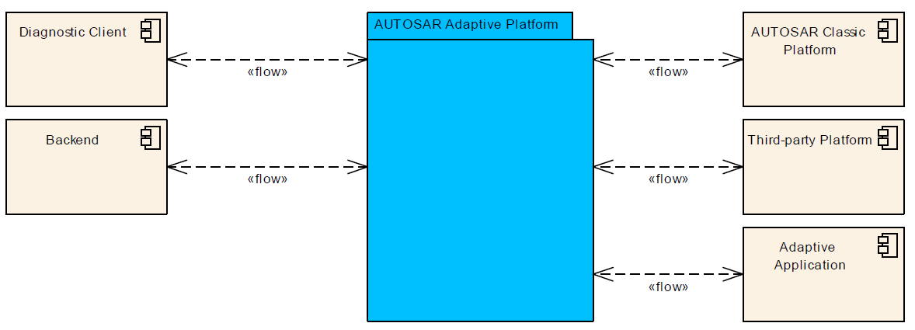

The AUTOSAR Adaptive Platform supports applications that are operated in heterogeneous environments. This section lists the external systems that AUTOSAR Adaptive Platform is intended to interface.

AUTOSAR Adaptive Application

There may be many Adaptive Applications deployed in a vehicle on different Machines. An Adaptive Application that does not run on the current instance of the AUTOSAR Adaptive Platform is therefore an external system to the AUTOSAR Adaptive Platform. Such Adaptive Applications may exchange data such as sensor or status information. During a software update of the entire vehicle, the update of the individual AUTOSAR Adaptive Platforms could be coordinated by a central Adaptive Application that makes use of the UCM Master addon to UCM.

AUTOSAR Classic Platform

The AUTOSAR Classic Platform is the main platform for deeply-embedded applications such as sensor/actor systems. Adaptive Applications may require access for example to sensor data provided by an AUTOSAR Classic Platform ECU and vice versa.

Third-party Platform

Besides both platforms (AUTOSAR Adaptive Platform and AUTOSAR Classic Platform) provided by AUTOSAR, there may be ECUs in a vehicle and other systems that are built on different platforms that need to communicate with an Adaptive Application via AUTOSAR Adaptive Platform.

Diagnostic Client

A Diagnostic Client uses the diagnostic services provided by the AUTOSAR Adaptive Platform.

Backend

A Backend system provides Software Packages for download and controls the update process via Update and Configuration Management.

AUTOSAR Adaptive Comm Stack requirements
The AUTOSAR Adaptive shall support standardized automotive communication protocols for intra ECU communication with different network topologies.

Compatibility
– An AUTOSAR Adaptive Platform stack implementation shall be capable of offering multiple versions of the same service.
– An instance of an AUTOSAR Adaptive Platform stack implementation shall be able to co-exist with other instances on different machines, within the same vehicle.

Usability
– An AUTOSAR Adaptive Platform stack implementation shall explicitly document restrictions on the application development that go beyond the standard.

Maintainability
– An AUTOSAR Adaptive Platform stack implementation shall be traceable to the contents of the standard.
– An AUTOSAR Adaptive Platform stack implementation shall support multiple versions of the same service.

Portability
– An AUTOSAR Adaptive Platform stack shall be portable to a different custom hardware.
– An AUTOSAR Adaptive Platform stack shall provide mechanisms to replace parts.

SOME/IP
SOME/IP Stands for Scalable Service-Oriented Middleware over IP
is an automotive/embedded communication protocol which supports remote procedure calls, event notifications and the underlying serialization/wire format:
- Remote Procedure Call (RPC) and Messaging
- Serialization
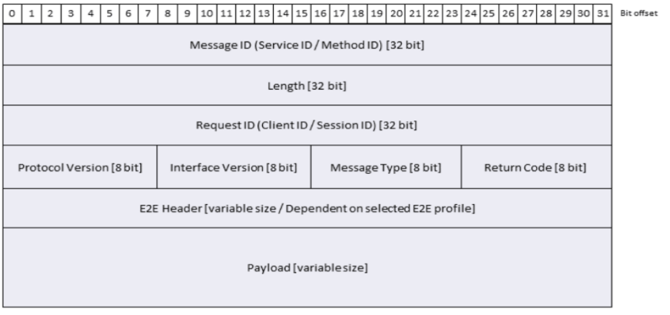

Remote Procedure Call (RPC) and Messaging

- Request/Response Methods: A request sent from a client to the server and a response sent back from server to client. Additionally, SOME/IP allows error responses to be sent back from server to client instead of the regular response. This feature might be used to implement a different payload format in error cases.

- Fire and Forget Methods: A request is sent from a client to the server.

- Event: An event is sent from the server to a relevant client. Which client needs this event will be determined via SOME/IP-SD.

- Field: A field can have an option notifier (event to be sent cyclically or on-change), an optional setter (a request/response method to update the field), and an optional getter (a request/response method to read out the current value of the field.

Serialization
SOME/IP can serialize the following complex datatypes:
- Struct
- String
- Array
- Enum

ARA::COM
Is a functional cluster and a part of "AUTOSAR Runtime for Adaptive Applications" ARA.

It is responsible for the construction and supervision of communication paths between applications, both local and remote.

The Communication management of AUTOSAR Adaptive can be logically divided into the following sub-parts:

• Language binding
• End-to-end communication protection
• Communication / Network binding
• Communication Management Software
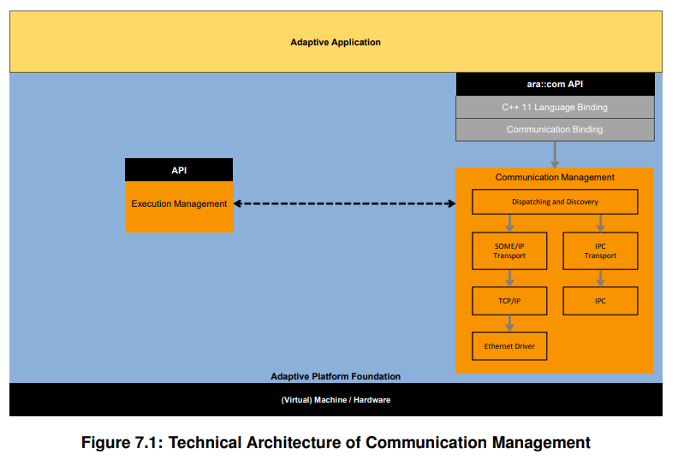

Service Discovery
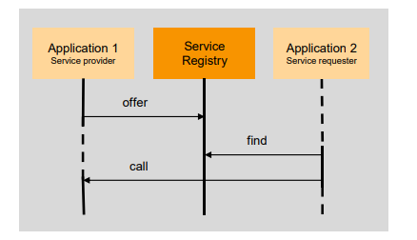
• This mechanism is responsible for finding and connecting the application request service with the application that provides this service.
• Each application that provides services, has a service registry
• To use a service, a consuming application needs to find the requested service by querying the service registry
• Service may be on local or remote ECU also on run time
• Service registry acts as a brokering instance and is also part of the communication management software
• Communication paths between communication partners can be established at design, at startup or at run-time

Design decisions

The design of the ARA API covers the following principles:

• It uses the Proxy/Skeleton pattern:
• The (service) proxy is the representative of the possibly remote (i.e., other process, other core, other node) service.
• The (service) skeleton is the connection of the user-provided service implementation to the middleware transport infrastructure. Service implementation class is derived from the (service) skeleton.
• Singleton provides some essentials to manage proxies and skeletons.

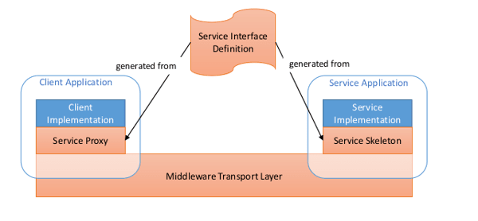

Service interface
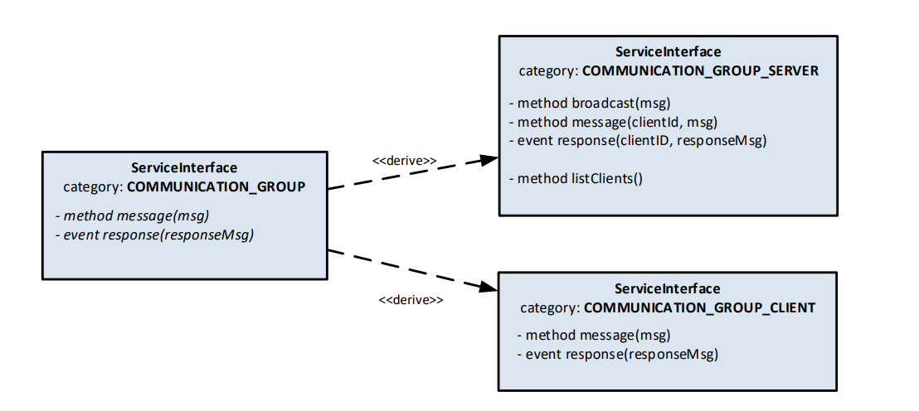


Resources

Software
- Vs code
- Build-Essential (g++, gcc)
- CMake
Programming Language: C++
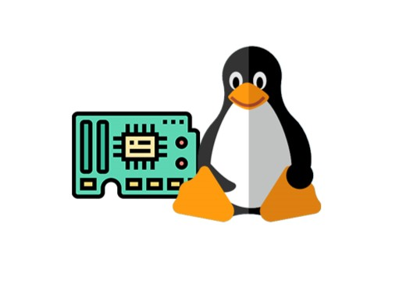
Operating System (OS): POSIX (Linux/Android)
Protocols: Ethernet, SOME/IP

Hardware
Boards
• 2 Raspberry Pi 4 model B 4GB

Other Instruments
• Ethernet Cables
• JTAG Debugger - For debugging embedded systems
• Soldering Kit - For circuit assembly
• Multimeter - For voltage and current measurement
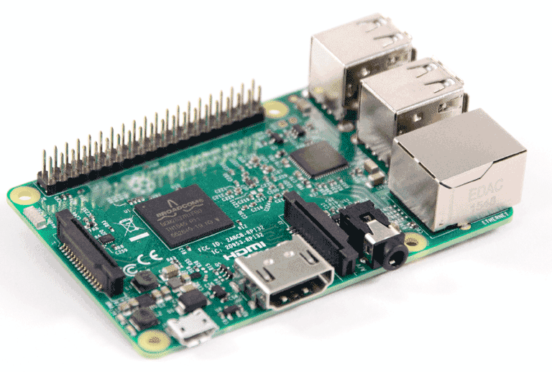
• Breadboards - For circuit prototyping
• Screen displayer

Sensors
• LIDAR Sensors
• Radar
• Side-View Cameras
• Gyroscopes
• GPS Module

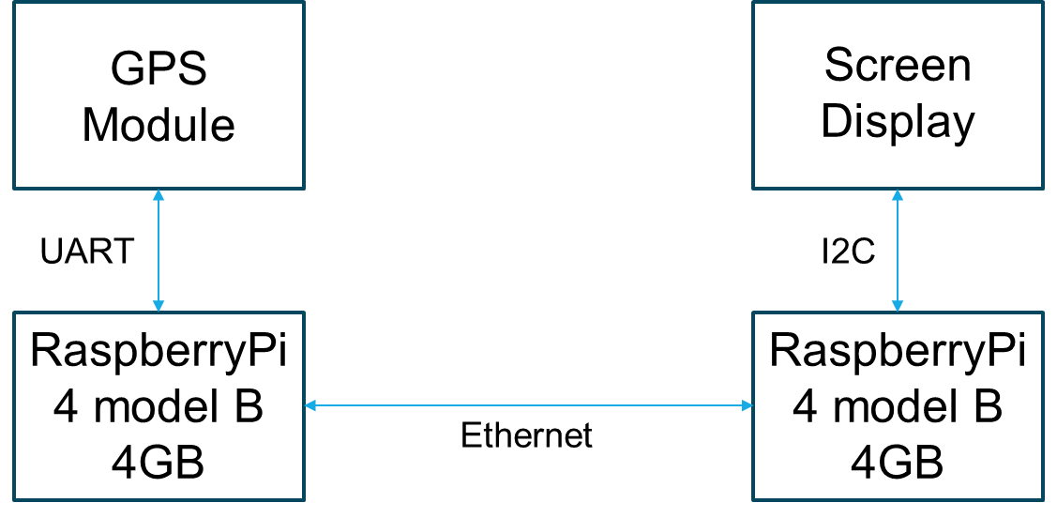

Agile methodology
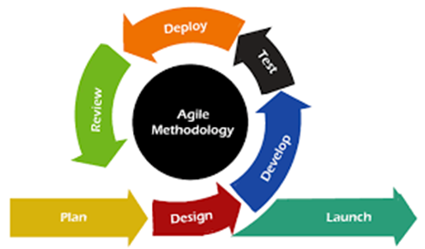
Agile Model:
Why Agile is better for our project:
Adaptive AutoSAR projects often involve evolving requirements and changing technologies, making the Agile process model a better fit. Here's why:
1. Flexibility: Agile allows for frequent changes and adaptations to requirements, which is crucial in adaptive projects where requirements may evolve over time.
2. Customer Involvement: Agile promotes active customer involvement throughout the development process, ensuring continuous feedback and alignment with their evolving needs.
3. Iterative Development: Agile's iterative approach enables the delivery of working software in short iterations, allowing for early validation and testing of AutoSAR components.
4. Collaboration and Communication: Agile emphasizes collaboration and communication within cross-functional teams, facilitating better coordination and integration of AutoSAR modules.
5. Learning and Continuous Improvement: Agile encourages learning from each iteration and incorporating feedback for continuous improvement, which is essential for adapting to new AutoSAR requirements and technologies.

Conclusion
In closing, Adaptive AUTOSAR emerges as a pivotal solution in response to the ever-changing landscape of the automotive industry. The burgeoning demands, such as autonomous driving, vehicle connectivity, and continuous updates, coupled with the influx of advanced resources like high-performance computing and ethernet communications, challenge the limitations of the existing AUTOSAR standard.
Adaptive AUTOSAR represents a beacon of order in this rapidly evolving ecosystem. It stands as a testament to the industry's adaptability and innovation, providing a crucial rule set to guide the transition and quell the potential chaos. Much like the original AUTOSAR standard revolutionised deeply embedded ECUs, Adaptive AUTOSAR is poised to usher in a new era for the next generation of vehicle computers.
In summary, Adaptive AUTOSAR is not just an evolution; it is a revolution, reshaping the automotive landscape and propelling us toward safer, smarter, and more connected vehicles. As we embark on this journey, it is with great anticipation that we anticipate the transformative impact of Adaptive AUTOSAR on the future of mobility.

References
[1] Explanation of Adaptive Platform Software Architectural
AUTOSAR_EXP_SWArchitecture

[2] Adaptive AUTOSAR for future automotive ECUs by Sreeraj Nair, Tata Elxsi

[3] Layered Software Architecture
AUTOSAR_EXP_LayeredSoftwareArchitecture

[4] SOME/IP Protocol Specification AUTOSAR FO R22-11

[5] Explanation of ara::com API AUTOSAR AP R22-11

[6] Specification of Adaptive Platform Core AUTOSAR AP R22-11

[7] Specification of Communication Management AUTOSAR AP R22-11

[8] Roman, P & Börge, S. “Adaptive AUTOSAR for high-performance in-car computers”
https://d23rjziej2pu9i.cloudfront.net/wp-content/uploads/2022/03/Trend-articles/Adaptive_AUTOSAR_for_high_performance_in-car_computers_Tech_paper_.pdf

[9] Martin, H & Alain, D. (June 27, 2022) “Adaptive AutoSAR in Autonomous vehicles” Retrieved from
https://www.automotiveworld.com/articles/autosar-is-the-backbone-of-avs-and-adas-but-for-how-long/

[10] Elias, H. (2020) "What Is Adaptive AUTOSAR?" Retrieved from
https://www.lhpes.com/blog/what-is-adaptive-autosar

[11] https://www.autosar.org/standards/adaptive-platform

[12] https://www.vector.com/int/en/

